

Date + Time: 2018-04-23 11:39

In care of:__________________________________________

Owner(s) of record: SHARON M LINDER Stephen G Linder 13 Cushing St Providence RI

Plat + Lot (A.P.).: 10/ / 232/ /

Site Information: 0001/ 001

Latest Book and Page: 0001/ 001

Land evidence chain: 6102/ 218 x x x

Zone:

Lot Area (Acres): 0.24+/-

All information from Assessors Database unless noted

Narragansett Engineering Inc is please to provide you with the following proposal, regarding:

Providence GIS + Aerial Map: 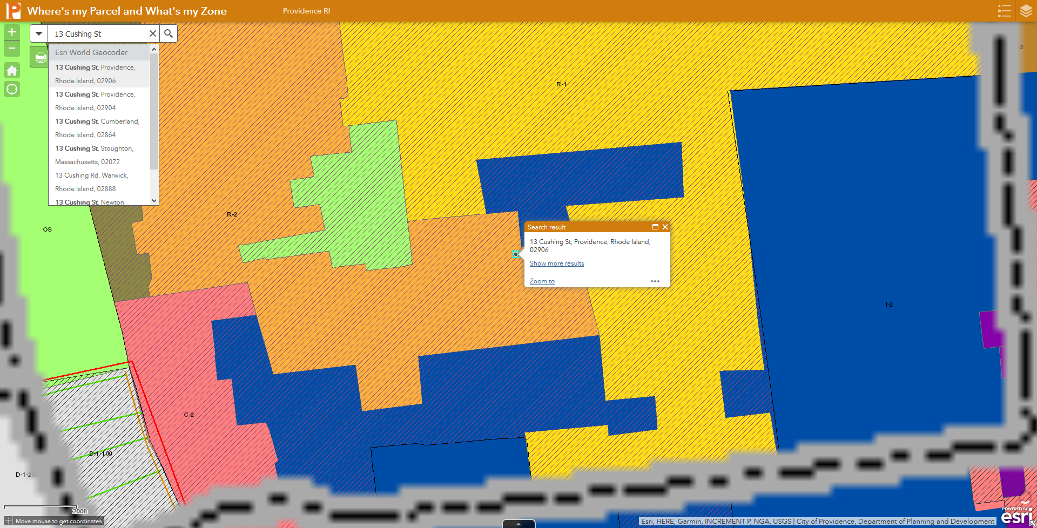

1.3 Construction Survey – Stake out for construction or property corners (specific features) Existing Survey and / Site Plan Required. Pre-Stake Sketch of Points / Feature to be set Construction Staking of Monuments and / or Markers to be set Set 2x Site Benchmarks (Typically) Post-Staking Sketch of Points / Features set. Specific Features to be set:__________________________ Estimated Cost: Hourly Rates.

NEI Standard Hourly Rates: Jan. 2018 Hourly Rates: Estimated costs are provided based on hourly rates, all fees shall be charged at the hourly rates stated. Additional work and work outside of scope shall be charged at hourly rates.  Not to exceed cost shall be billed at hourly rates or percent complete, up to, but not to exceed, the stated amount for the requisite scope of work) -Survey Crew (Field, Robotic and / or GPS):       $200 per hour   (field Survey, layouts), -Staff Rates:                                                         $140 per hour (design, drafting, CAD), -Sr. Staff (Project Manager):                                $175 per hour (structural or civil analysis), -Principal: $185 per hour, -Soil Evaluator:                                                     $775 half day   (1-2 test locations and report), -Admin:                                                                $75 per hour, Notes:  
  
Standard Notes:  
  
Any work requested outside the scope of this proposal shall be charged at current hourly rates which can be found on our website (www.nei-cds.com), or, subsequent contract terms and rates.  
Rates for professional testimony or meetings after-hours will be increased by a factor of 1.4  
Any subcontractors retained by NEI on behalf of the client shall be billed at a multiple of 1.2 times.  Sub consultants may include, but are not limited to, Professional Wetlands Scientists, Soils testing labs, Environmental Professionals, structural and materials testing, and similar services.  NEI maintains no liability as to subcontractor performance, this services is provided as a courtesy only, subcontracts shall be the direct responsibility of owner  
NEI reserves the right to disseminate any documents created in the scope of the project and recorded in the public domain to any interested third party  
Add item - may be required in addition to base fee  
Alternate item - may be alterative means to approval, alternate selection is possible.  
NEI may require construction or post-construction inspections to be performed to verify construction conforms to design plans and minimum code standards. Failure to approve or allow these inspections may compromise design goals and integrity and may limit NEI's liability in such cases.  
NEI and its consultants, partners, agents and employees shall not be liable for any and all claims, losses, expenses, injuries, or damages arising out of or any way related to this Project or this Agreement by reason or any act or omission, including breach of contract or negligence not amounting to a willful or intentional wrong, shall not exceed the total compensation received by NEI under this Agreement.  
 No filing fees (Federal, State, Local or otherwise) are included within this proposal unless note otherwise. All fees to be paid by Owner /Applicant. A $25 fee is charged for all checks paid by NEI; any checks over $500 will be required to be paid directly by client or pre-paid.  
This proposal is valid for 45 days. A retainer of $00.00 is requested with the acceptance of this if this proposal is acceptable to you, please sign one copy and return it to my office with the specified retainer. Retainer is non-refundable. Billing shall be performed at monthly intervals with retainage billed first. Invoice balances held for greater than 30 days may incur a finance charge of 2.0% per month. Balances held over 6 months may be placed in collection; including finance and collection fees.  
We reserve the right to redeposit returned checks, redeposit fees will be charged to client.  
Processing fee of up to 3% (min. $15) may be applied for credit card payments  
Credit Card payments can be made over the phone during normal business hours.  
Wire Transfers Fees:    
Payments for invoices of $1,000 or more shall not incur any wire transfer fees.  Payments of less than $1,000 shall be responsible for transfer fees.  
Work may be terminated at any time, though all items performed to date shall be billed as per percent complete or  per time spent.  
Project will not commence until retainer is paid. Nonpayment of monthly invoices may result in work delay or lower priority job status

Survey+Site Design Notes (Sec. 1 + 2) Property disputes, litigation, arbitration or similar issues are not included within this proposal. Additionally, deed or property errors caused by past recording errors, encroachments, non-conforming structures, adverse possession, or takings may require additional services to resolve outside the scope of this proposal.  Meetings (outside the proposal scope) and prints shall be charged at hourly / standard rates. Abutters lists, mailings, etc. not inclusive Probate record search not inclusive in typical research package. If owner is able to supply a current title search dating back to operative document (e.g. lot creation), discount for survey cost may be applied. Survey Marker + Monuments Materials Cost (Billable unless noted otherwise): Witness Stake - $2 / per Rebar + Witness Stake - $10 / per Pin w/ cap + Witness Stake - $15 / per Feno bounds w/ Stake - $85 / per Granite or Concrete Bounds - $200 / per* *All bounds may incur hourly rate fees due to difficulty of installation, boulders, subsurface impediments, etc. Significant clearing of brush or line cutting is not included unless noted. If clearing is required it shall be performed by owner or charged at hourly rates. Field staking trips require at minimum 48 hours prior notice, i.e. 2 business days. Stakeouts calls that are received later than this will be charged a rush rate at a multiple of 1.4. This does not guarantee service within 2 days. All request for survey and staking, must come through the main office, field staff may not be able to process scheduling directly. Stake out / construction layout procedure. Upon receipt of request for layout from client, NEI will prepare a Pre-Stakeout Sketch (SK) of the points desired to be set. An email will be sent to client / responsible charge displaying these points. Client will need to approve the location of points, via email, prior to item being placed on field schedule, minimum 24 hours prior to date of fieldwork.   
Upon completion, NEI will provide a Post-Stakeout SK, displaying actual points set for record information.  
NEI recommends having all survey plans recorded in land evidence. This can be performed by the owner, there is a fee to record in land evidence (varies by municipality), though a Mylar print will need to be used ($85 per).  
Any excessive issues arising during construction not due to engineering plans or specifications ie: contractor error, negligence, malfeasance, or unforeseen or unknowable site conditions (i.e.: Spearin Doctrine) or conditions arising from inclement weather and/or natural disasters are not inclusive and may require additional services outside above referenced scope of work.   
Any work required to be performed earlier than 8.00a or later than 4.30p Monday through Friday, or any work required to be performed on a weekend or Federal or State Holiday will incur overtime rates (1.5x to 2x)  
Landscape Architecture Plans or design area not inclusive unless noted otherwise  
Traffic analysis, counts, testimony not inclusive unless noted otherwise.  
Photometric Plan not inclusive unless noted otherwise.  
Geotechnical analysis or borings not inclusive unless noted otherwise.

Assesors Database Information Continued: From assessors datatabase: 2018-04-23 11:39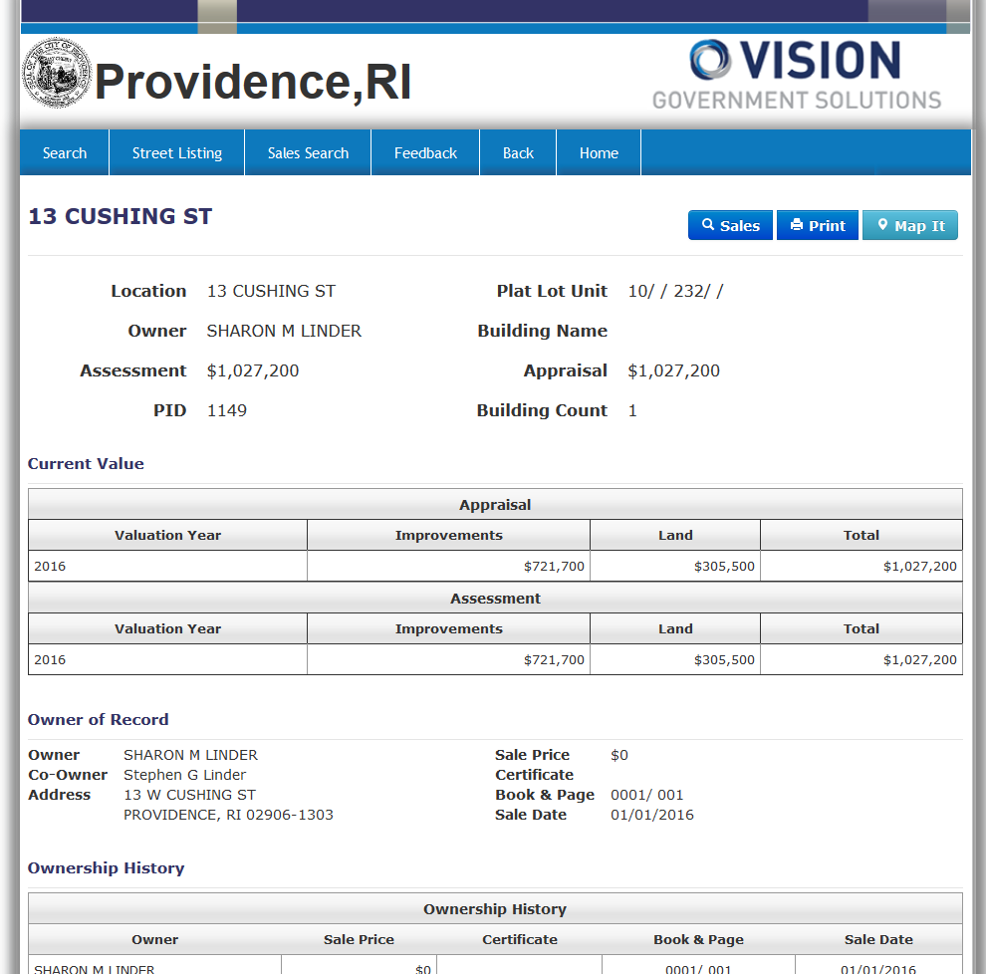

Assesors Database Information Continued: 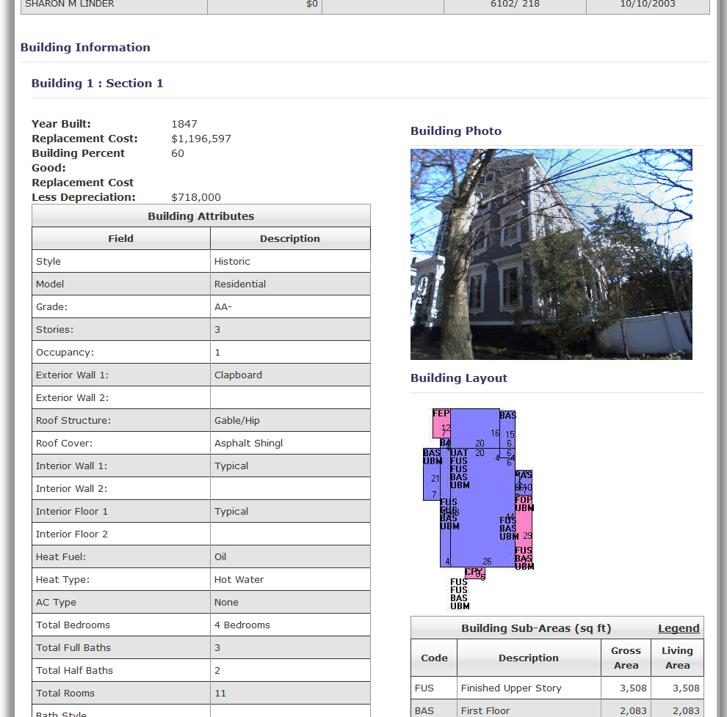

Assesors Database Information Continued: 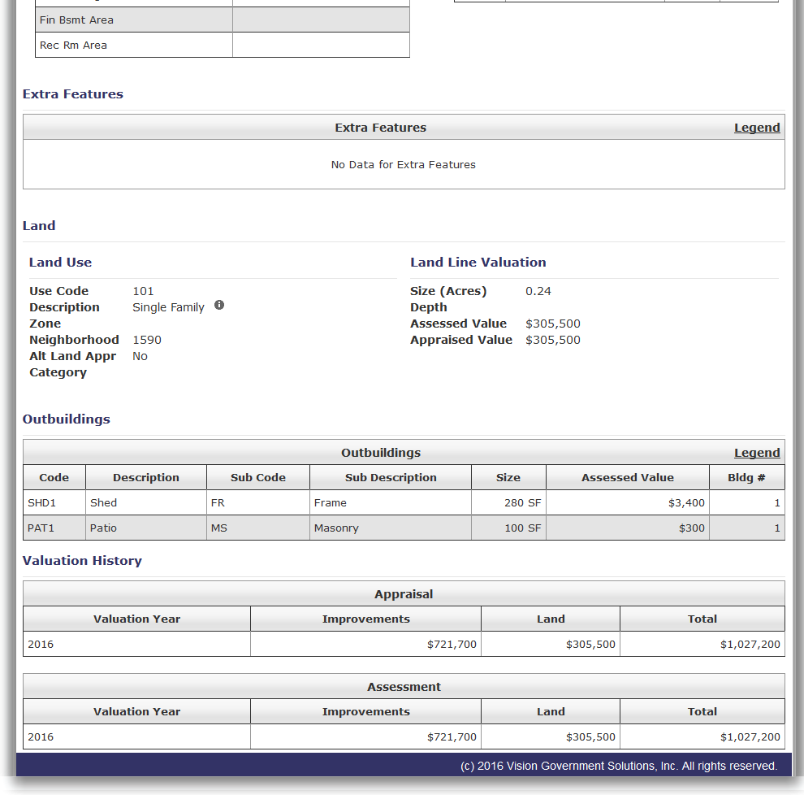

RIDEM GIS Soils, Wetlands, Flood Zone: 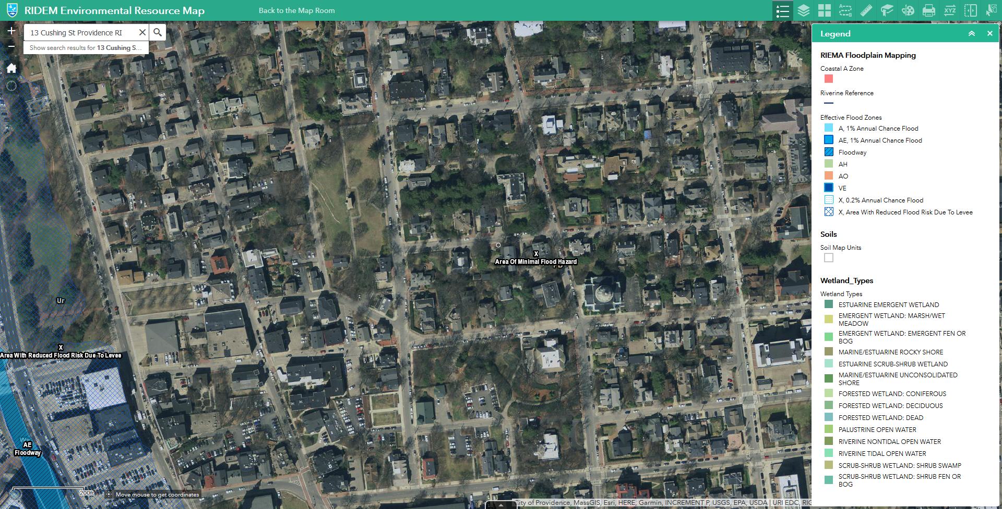

FEMA GIS Information: 